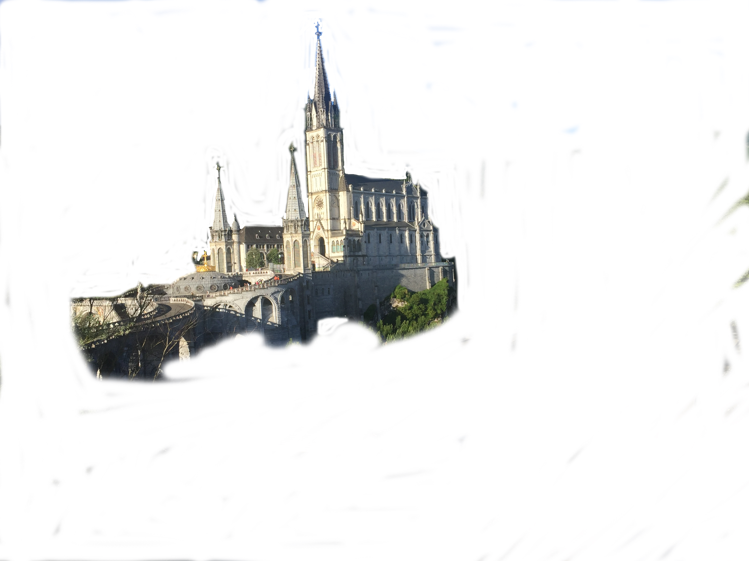

Contact us if you have any questions
We had a really special pilgrimage in 2019 and are thrilled to be doing it all again next year, hopefully with you in a yellow t-shirt! In addition to the week in Lourdes, the overland trip will take in a visit to Tours, Orleans and a couple of days holiday in Disney Paris on the journey home.
If you would like to join us as a volunteer in 2020, please complete and return this application ASAP to reserve your place.
Please note that the actual cost of the trip for 2020 is estimated at £1075. If you wish to pay up to that amount to cover some or all of the subsidy we would be very grateful for any additional payments. If you need help with fund-raising, get in touch with us.

Cost

The cost of this year’s coach trip will be £800 + spending money.

Deposit of £100 due with the completed form ASAP, by end of November at the latest

Cheques payable to

Dunkeld Lourdes Service

OR

Direct payment through your bank to

Sort Code: 83-18-32

Account No: 00137398

Include your name as payment reference

Let us know when you make payments please
Dunkeld’s Lourdes pilgrimage will take place from:
Friday 10th – Friday 17th
July 2020

The bus journey will run from:
Tuesday 7th – Tuesday 21st July 2020

Lourdes 2020

When?
  - 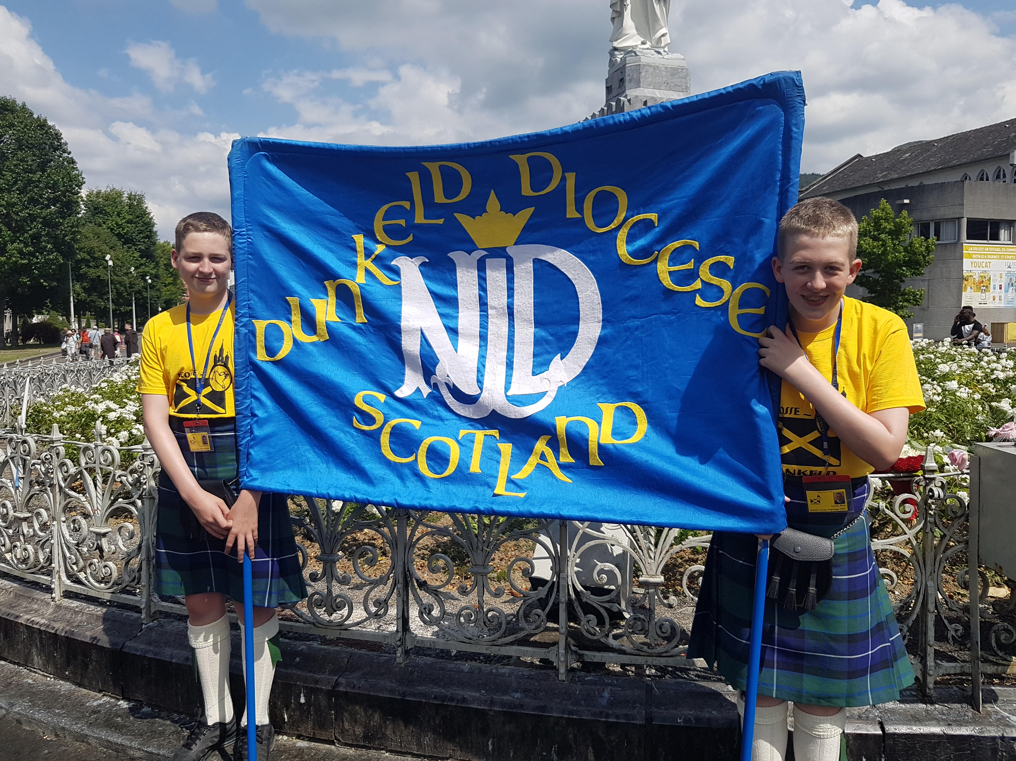

  - 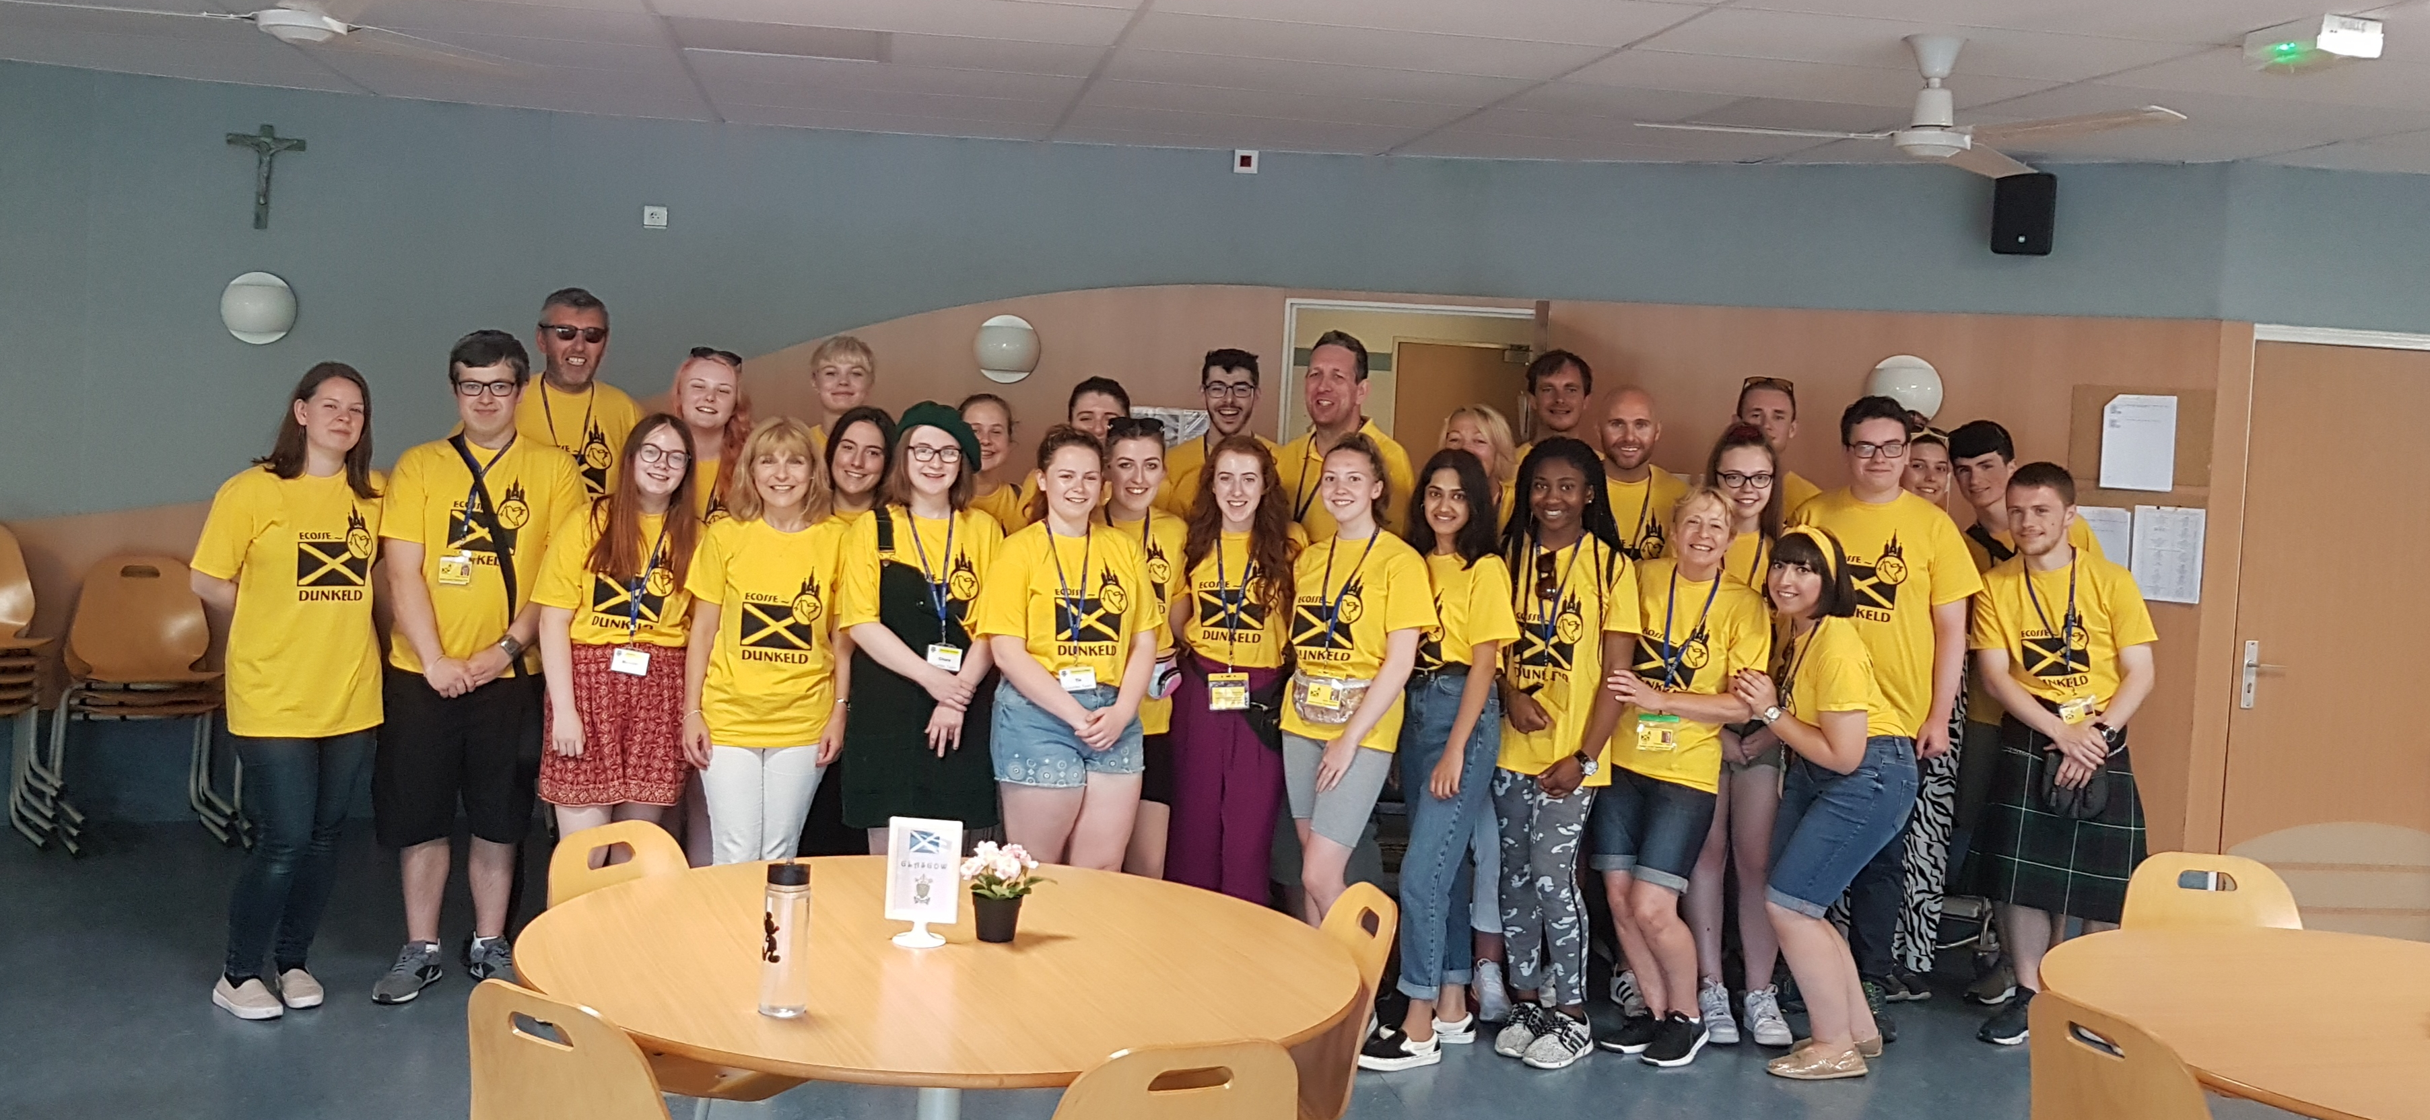
Pluscarden, Station Road,
Errol Station, Errol, Perthshire PH2 7SN
Please either email (18+only) or post your application.
You can reach us at:
dunkeldlourdesservice@yahoo.co.uk
(Watch out for that double “s”!)
Phone:
01821 642634

Email:

Mail

Yellow Pages
the
Application edition
Application form
This form is for everyone planning to join the Dunkeld Lourdes 2020 Pilgrimage as a Yellow Tshirt

Please complete this form and return by post or email to the contact details on the first page ASAP, by end of November 2019 at the latest.
We cannot guarantee a place for you if you don’t return this form by this date.
Note that you will require additional travel documents and personal insurance, and will be contacted by Group Leaders to gather this information.

Your name (for ID badge):
Do you have a passport? |  | Yes ☐ No☐ |  |  |  | Passport Number:
 |  |  |  |  |  | Expiry Date:
Full name (as on passport or birth certificate):
Date of Birth:
Address (including postcode):
Email Address: (we’ll use this to contact you so check it regularly, and let us know of changes please!)
Home Phone: |  |  |  |  |  | Mobile:
Parent/Guardian Contact Details (U18 only): |  |  | Name:
 |  |  | Email:
 |  |  | Mobile:
These details will be used to provide information prior to the trip, summarise money owed and paid, and may be used to keep you up to date with the pilgrimage whilst we are away. We will use your personal information for the purposes of the Diocesan Pilgrimage only.
Parish:
How do you intend to travel? | Coach  ☐ |  |  |  | Pilgrimage Flight  ☐ |  | Own Arrangements  ☐
For coach travelers, any special requests for accommodation in hotels or ferry? Single rooms have a supplementary cost. Any special requests / needs on the coach?
Any medical conditions or particular dietary needs we should be aware of?
Emergency Contacts
Name: |  | Relationship to you:
Address: |  | Home phone:
Address: |  | Mobile:
We sometimes send you news, events and fundraising information by email and/or text throughout the year. If you do not wish to be on our mailing list please tick this box. ☐
On occasion, photos are taken of Dunkeld volunteers for pilgrimage promotion. If you do not wish this, tick this box. ☐

Parent / Guardian signature_______________________________

Date ______________________

Lourdes July 7th-21st 2020
If you are under 18 years of age please ask your parent/guardian to print, complete and post this part of the form. Please return to Pluscarden, Station Road, Errol Station, Errol, Perthshire PH2 7SN

Full name of under 18 young adult mentioned overleaf |  | Young adult’s date of birth
Name of Parent/Guardian |  | Relationship to young adult

- I hereby apply for a place on the Dunkeld Pilgrimage to Lourdes in July 2020, and I give full consent for a named Adult Group Leader to take my child, named above, through passport and border control out of, and return to, the UK and EU for this purpose.

- As far as I am aware, my child has not been in contact with any infectious diseases for the last three weeks and are in good health. I wish to declare the following medical conditions, and prescribed medications that the Dunkeld Lourdes Group Leadership Team should be aware of:

- I hereby consent to the disclosure of medical and other relevant information about my child to Dunkeld’s medical advisers, the relevant Group Leaders and any other person as Dunkeld Lourdes deems appropriate in my child’s best interests.
- I hereby give consent for my child named above to receive any necessary medical treatment recommended by the professionals working within the French healthcare system.
- In the event of this young person being taken ill during the period of the above event to the extent that a surgical operation or a serum injection becomes necessary, I authorise the relevant Group Leader to sign on my behalf any forms of consent requested by the medical authorities provided the delay required to obtain my own signature might be considered likely in the opinion of the doctor or surgeon concerned to endanger this young person’s health or wellbeing.
- Neither signatory nor the Diocese of Dunkeld Lourdes Pilgrimage, its servants or agents, shall be under any liability as the result of signing the form of consent that the parents will indemnify the signatory, Diocese of Dunkeld Lourdes Pilgrimage, its servant or agents in respect of any claim by their child as a result thereof.
- I understand that during the period of the above event this young person will be in the charge and under the instruction of the Group Leaders, and that while the Leaders will take all reasonable care of him/her, they cannot be held responsible for any loss, damage or injury suffered by this young person arising during or as a result of the event. The leaders, Diocese of Dunkeld Lourdes Pilgrimage, its servant or agents cannot be held responsible for any loss or damage to personal effects. The parents will indemnify the leaders, Diocese of Dunkeld Lourdes Pilgrimage, its servants or agents against any claim instituted by or on behalf of their child.

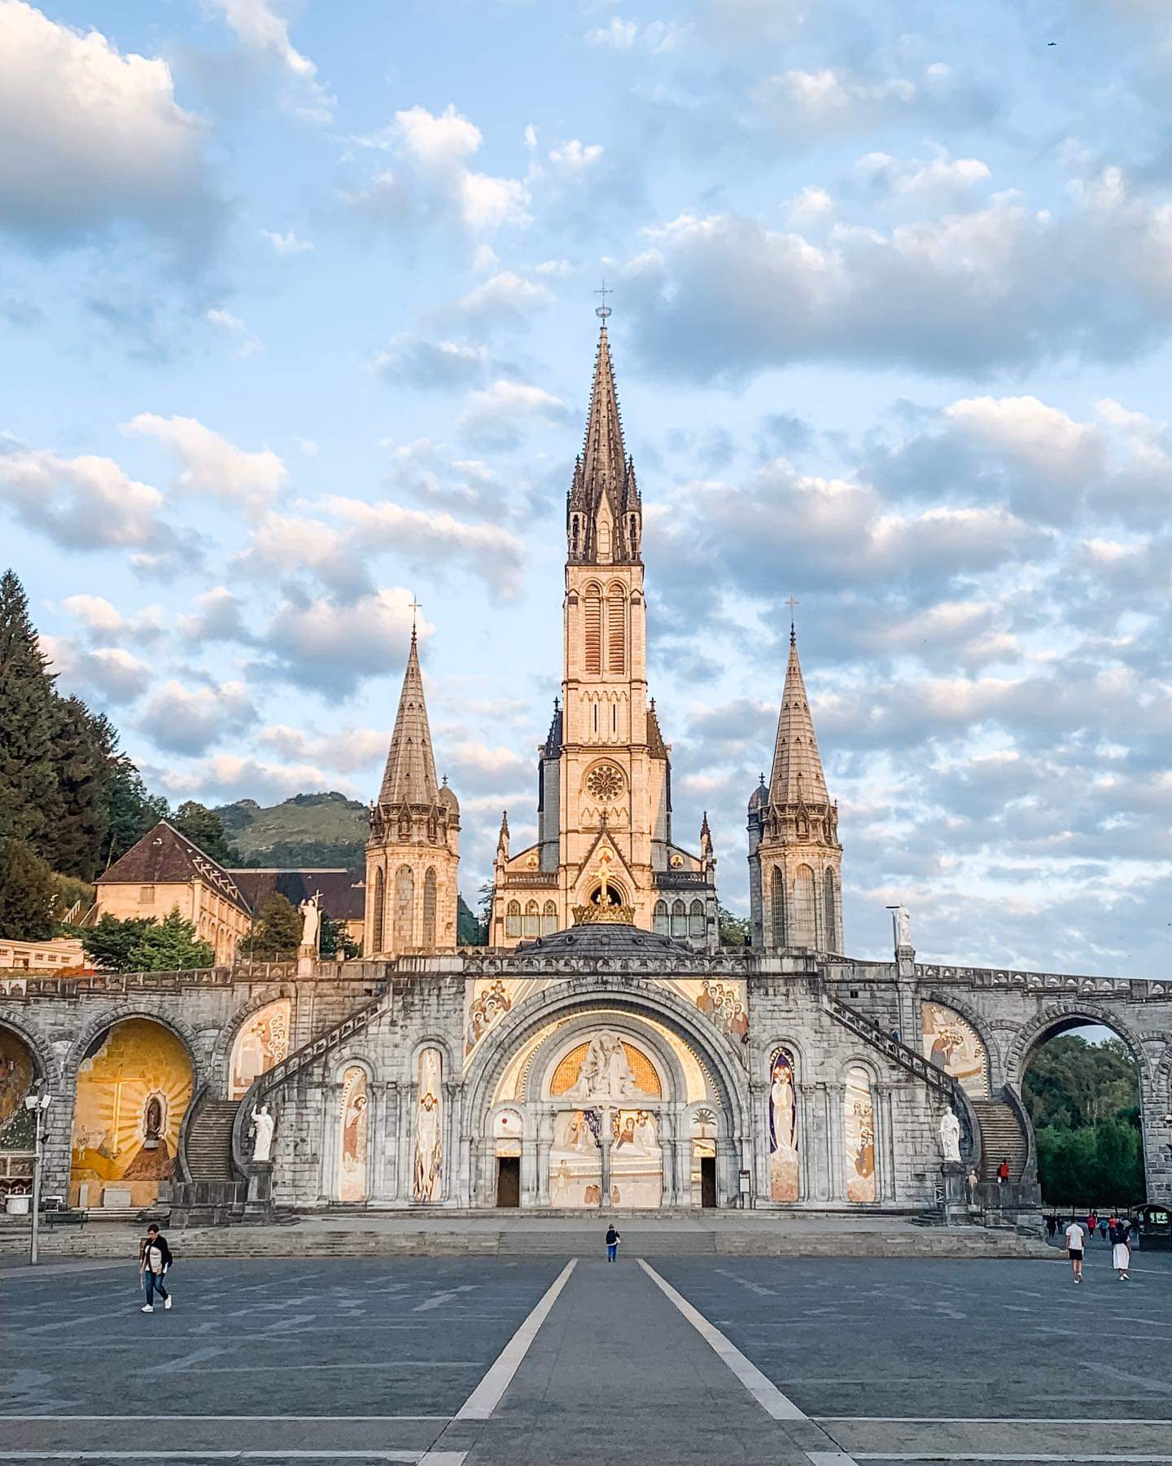 Parent/Guardian Signature: ________________________________________

Date: ________________________
Parent/Guardian Declaration

